**ALGORITHM (30 Points)**

set score_sum to 0

set count to 0

display welcome screen

while True:

display menu

get valid option from user

if option == “A”:

get input for name

get input for score

while score < 18 or score > 150:

display error message

get input for score

write name and score to goal.txt file

score_sum = score_sum + score

count = count + 1

elif option == "B":

average = score_sum / count

display average

write average score to AverageScores.txt file

else:

exit the program

**VARIABLES/CONSTANTS (5 points)**

score_sum (float)

count (int)

option (string)

name (string)

score (float)

average (float)

**FORMULAS (5 points)**

score_sum = score_sum + score

count = count + 1

average = score_sum / count

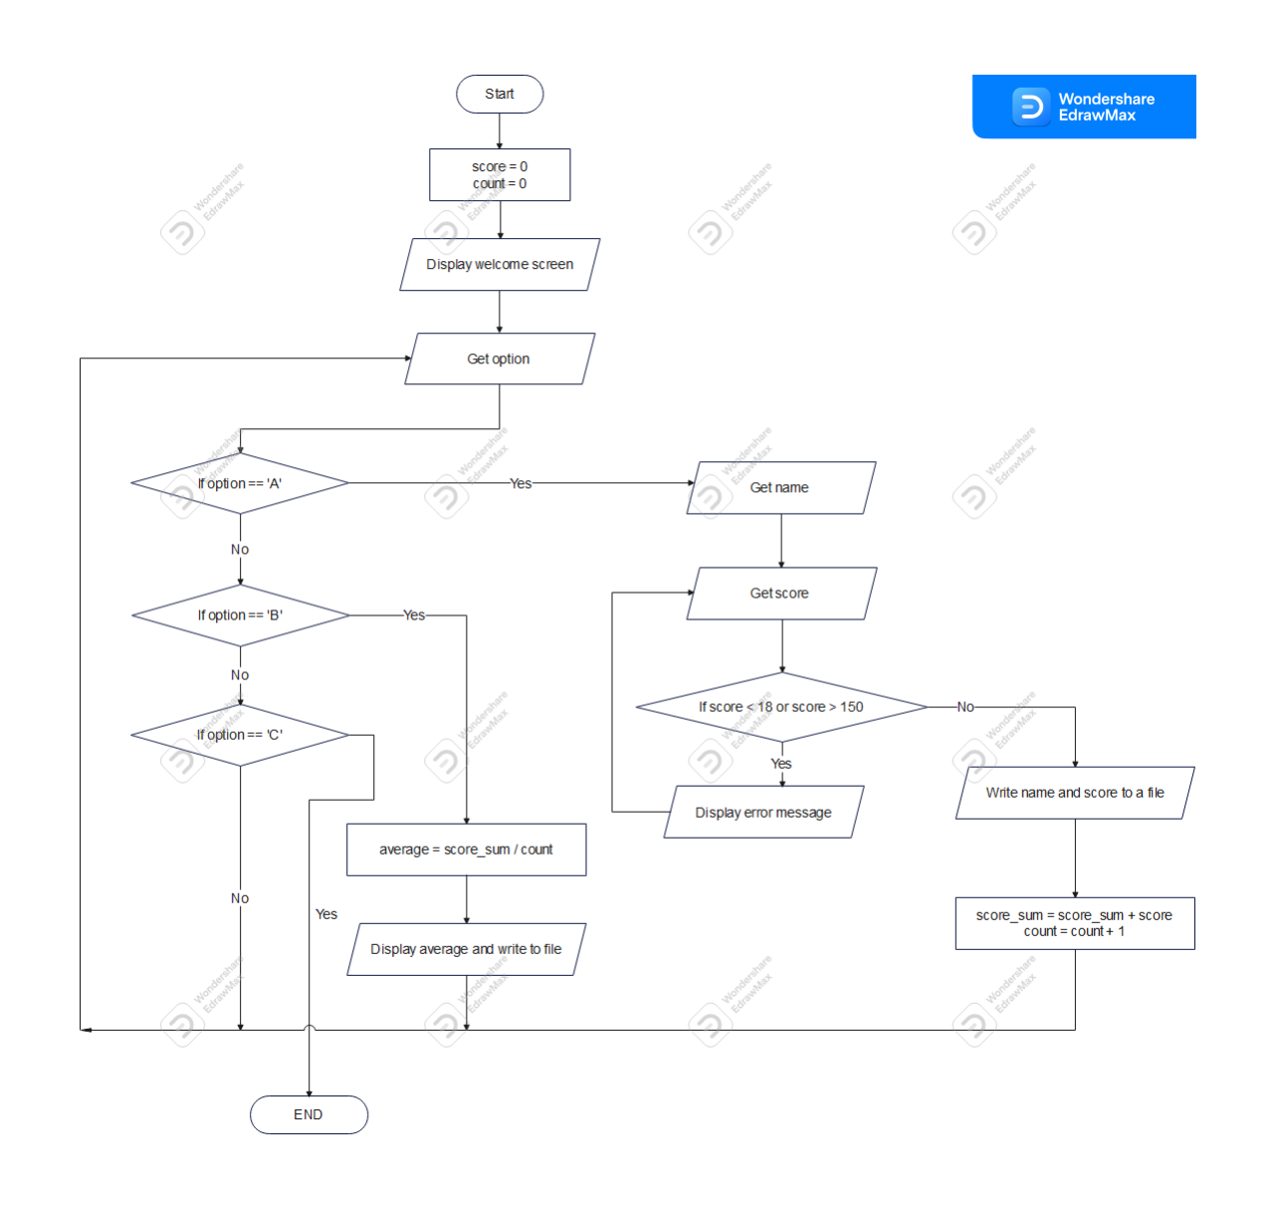**FLOWCHARTS – One flowchart per function - (10 Points)**

**TEST DATA – 5 complete data sets (10 points)**

You can place in Excel file if you embed into Word and submit the Excel file

|  |  |  |
| --- | --- | --- |
| **Input (Use variable names)** | **Process (Formula)** | **Output (Expected Results)** |
| Michael  30  Kevin  20 | score_sum = 30 + 20 = 50  average = 50/2 = 25 | Michael 30  Kevin 20  Average : 25 |
| Sara  50  Angel  40  Clara  30 | score_sum = 50 + 40 + 30= 120  average = 120/3 = 40 | Sara 50  Angel 40  Clara 30  Average : 40 |
| Peterson  19 | score_sum = 19  average = 19/1 = 19 | Peterson 19  Average : 19 |
| Peter  45  Kevin  20  Ronaldo  25 | score_sum = 45 + 20 + 25= 90  average = 90/3 = 30 | Peter 45  Kevin 20  Ronaldo 25  Average : 30 |
| Dany  43  Daniel  32  Neon  73  Roger  18 | score_sum = 43 + 32 + 73 + 18= 166  average = 166/4 = 41.5 | Dany 43  Daniel 32  Neon 73  Roger 18  Average : 41.5 |

**PYTHON CODE (30 Points)**

# Global variables

score_sum = 0

count = 0

# Open golf.txt file

file1 = open("golf.txt", "w")

# Function to get input for option

def getOption():

# Get input from user

option = input("\nEnter option: ").upper()

# If it is not valid get input again

while option not in ["A", "B", "C"]:

print("Invalid option")

option = input("Enter option: ").upper()

return option

# Function to display menu

def displayMenu():

print("\nA. Enter Player’s Name and Golf Score\n"

"B. Calculates Average Score\n"

"C. Exits the program")

# Function to get player details

def getPlayerDetails():

global score_sum

global count

# Get name and score from user

name = input("\nEnter player name : ")

score = int(input("Enter player score : "))

# Validate score input

while score < 18 or score > 150:

print("Invalid score")

score = int(input("Enter player score : "))

# Write name and score to goal.txt file

file1.write(f"{name}\t{score}\n")

# Increment score_sum and count

score_sum += score

count += 1

# main function

def main():

# Display welcome screen

print("-------------------------------------------------------------")

print("| The Springhill Amateur Golf Club Tournament |")

print("-------------------------------------------------------------")

while True:

# Display menu

displayMenu()

# get option from user

option = getOption()

# If option is 'A' call getPlayerDetails function

if option == "A":

getPlayerDetails()

# If option is 'B'

elif option == "B":

# Calculate average

average = score_sum / count

# Display average

print(f"\nAverage : {round(average, 2)}")

# Write average to AverageScores.txt file

file2 = open("AverageScores.txt", "w")

file2.write(f"Average : {round(average, 2)}\n")

file2.close()

# If option is 'C' exit the program

else:

break

file1.close()